Travel Packing List
(Summer edition)

Suitcase
- Blouses / nice tops x__
- T-shirts / casual tops x__
- Jeans / pants / trousers x__
- Shorts / skirts x__
- Dresses / suits (1 casual, 1 nice)
- Sweater or light jacket x__
- Pajamas x2
- Underwear x__
- Socks x__
- Bras x__
- Bathing Suit x__
- Sandals x__
- Dress shoes
- Toiletries
- Laundry bag

Carry-on / Handbag
- ID, passport
- Wallet
- Travel documents (i.e. vaccination certificate, Visa)
- Phone
- Reading material
- Computer, tablet
- Headphones
- Charge cords and adapters
- Face mask
- Sanitizer / anti-bac wipes
- Hand cream, lip balm
- Medicines, vitamins
- Sunglasses
- Light sweater, jacket or scarf
- Snack

Toiletries
- Face wipes / cleanser
- Face moisturizer, creams, serums
- Toothbrush & paste
- Make-up
- Shampoo, conditioner, body wash
- Hairbrush/comb, ties, clips
- Curling / flat iron
- Hair spray, cream
- Nail file, clippers
- Razor
- Deodorant
- Add item…

Optional Add-ons
- Moisture / odor absorbers
- Waterproof bag (wet swimsuit)
- Flat/foldable tote for one-way travel items (i.e. gifts & souvenirs)
- Backup battery / power bank
- Stain remover
- Portable steamer
- Compression socks
- Ear plugs / eye mask
- Neck pillow
- Gym clothes & shoes
- Belt
- Alternate handbag / clutch
- Hat
- Sunscreen
- Bug Spray
- Mary Poppins mini kit (band-aid, safety pin, rubber band, hair tie, hair pin, nail file)
- Gifts
- Music speaker
- Streaming device
- International SIM card

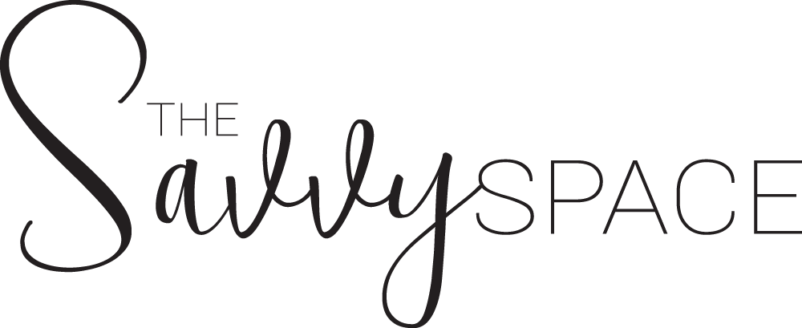
Travel Packing List - Kids
(Summer edition)

Suitcase
- Outfits x2 per days of travel
- Light sweater or jacket x1
- Underwear
- Socks
- Pajamas
- Shoes
- Swim suit
- Toiletries

Toiletries
- Toothbrush, toothpaste
- body wash
- shampoo, conditioner
- moisturizer
- sunscreen, after sun lotion
- Hairbrush / comb
- Hair ties, clips

Carry-on / backpack
- Wipes, tissues
- Change of clothes
- Pjs
- Plastic or water-proof bag
- Water bottle (emptied)
- Snacks
- Entertainment (book, tablet, 1 activity / 2 hours of flight)
- Headphones
- Sweater or light jacket

Optional Add-ons
- Comfort item (i.e.blanket, pillow, toy)
- Gum, lollipop, hard candy
- Medicine, vitamins
- Towels
- Swim gear (Arm band floaties, goggles)
- Beach gear (toys, float)
- Hat
- Sunglasses
- Sunscreen, after sun lotion

Baby/Toddlers
- Diapers / training pants
- Formula / milk / baby food
- Bottles
- Breast pump
- Sippy cups
- Pacifier
- Burp cloth
- Sterilizer
- Baby carrier
- Stroller / push-chair
- Car seat, booster seat

Travel Prep List
(Summer edition)

Admin - Personal travel
- Hotel arrangements
- Transportation arrangements (rental car, airport to/fro)
- Child care arrangements
- Pet care arrangements
- Pre-pay / pre-arrange bills
- Print or download travel documents (i.e. vaccination card, Visa)
- Download articles, TV shows and/or movies for offline entertainment
- Charge up electronics
- Schedule an email auto response message
- Check-in for flight

Admin - Empty house / extended trip
- Clean out refrigerator
- Empty dishwasher (door cracked open)
- Empty dryer & washer (washer door open)
- Take out the trash
- Leave a house key with a trusted friend or family member
- Hold mail at the post office or arrange for collection

